CI/CD (Codebuild & CodePipeline) Pipeline Deployment on Amazon EKS

Project Overview
This project demonstrates a complete CI/CD pipeline to deploy a containerized React application to Kubernetes using Amazon EKS.
The pipeline automatically:
- Pulls source code from GitHub
- Builds a Docker image
- Pushes image to DockerHub
- Deploys to Amazon EKS cluster
- Exposes application using Kubernetes LoadBalancer

Technologies Used
- GitHub
- AWS CodePipeline
- AWS CodeBuild
- Docker
- DockerHub
- Amazon EKS
- Kubernetes
- Amazon CloudWatch (for logs)

CI/CD Pipeline Stages

Source Stage
- Triggered on push to main branch

Build Stage
- Builds Docker image
- Pushes image to DockerHub
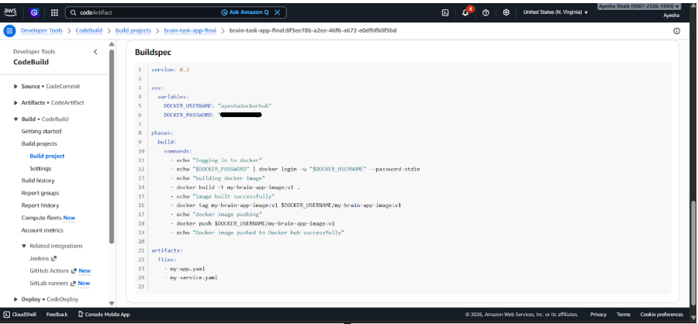
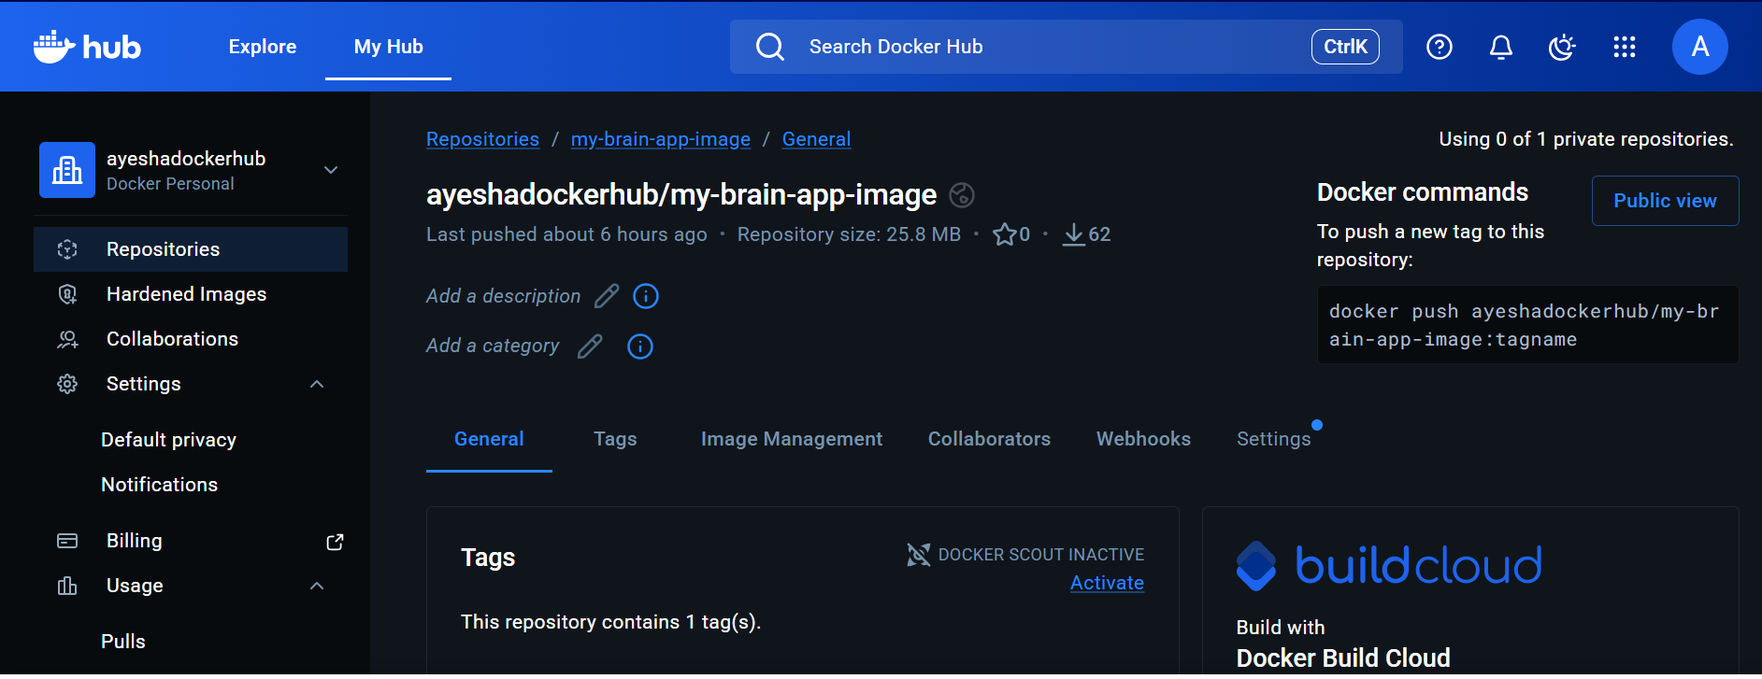

Deploy Stage (CODE PIPELINE)
- Uses kubectl
- Applies my-app.yaml
- Applies my-service.yaml
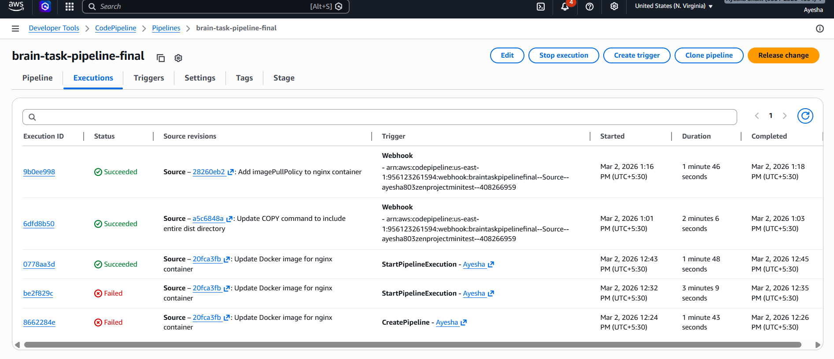
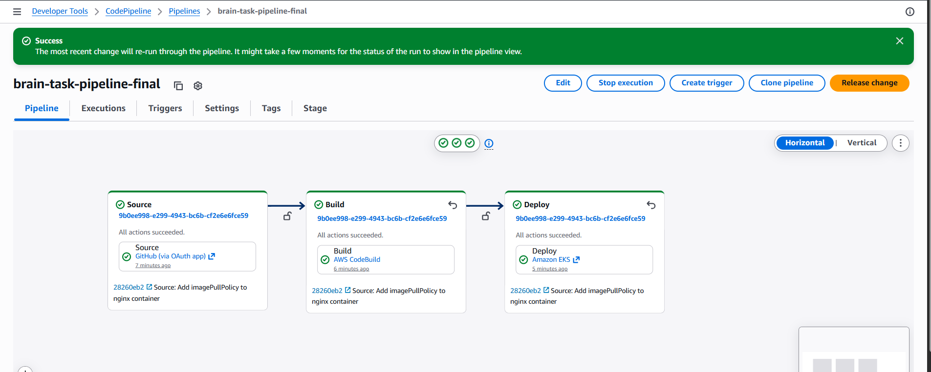

Kubernetes Deployment
- Deployment: nginx-deployment
- Service: LoadBalancer
- Cluster: brain-tasks-cluster
- Region: us-east-1
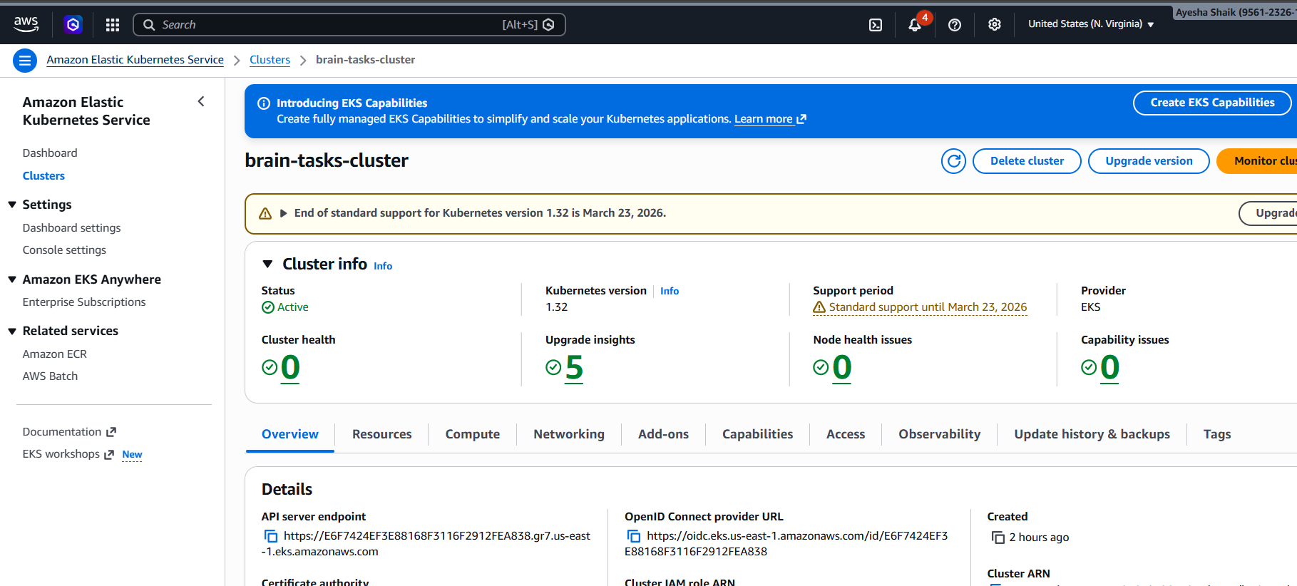
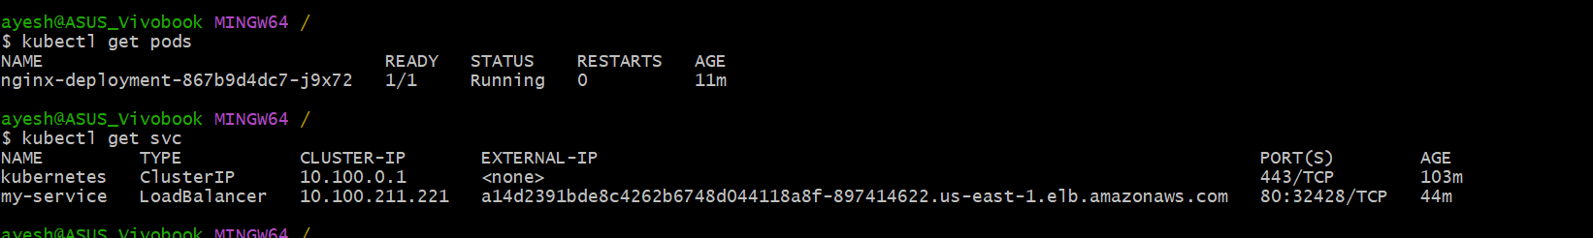

Monitoring
- Build logs stored in CloudWatch
- Deployment logs visible in CodePipeline
- Application accessible via LoadBalancer URL
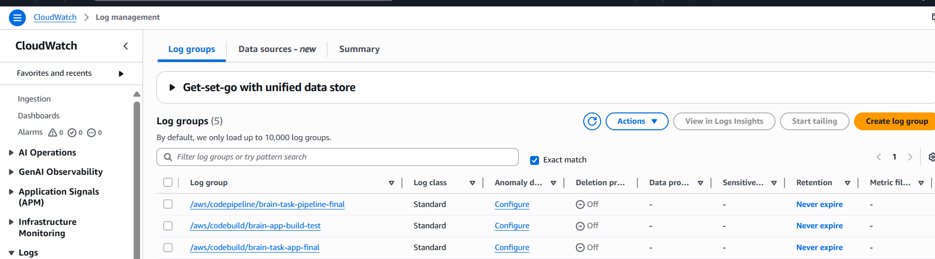
Application URL
http://a14d2391bde8c4262b6748d044118a8f-897414622.us-east-1.elb.amazonaws.com

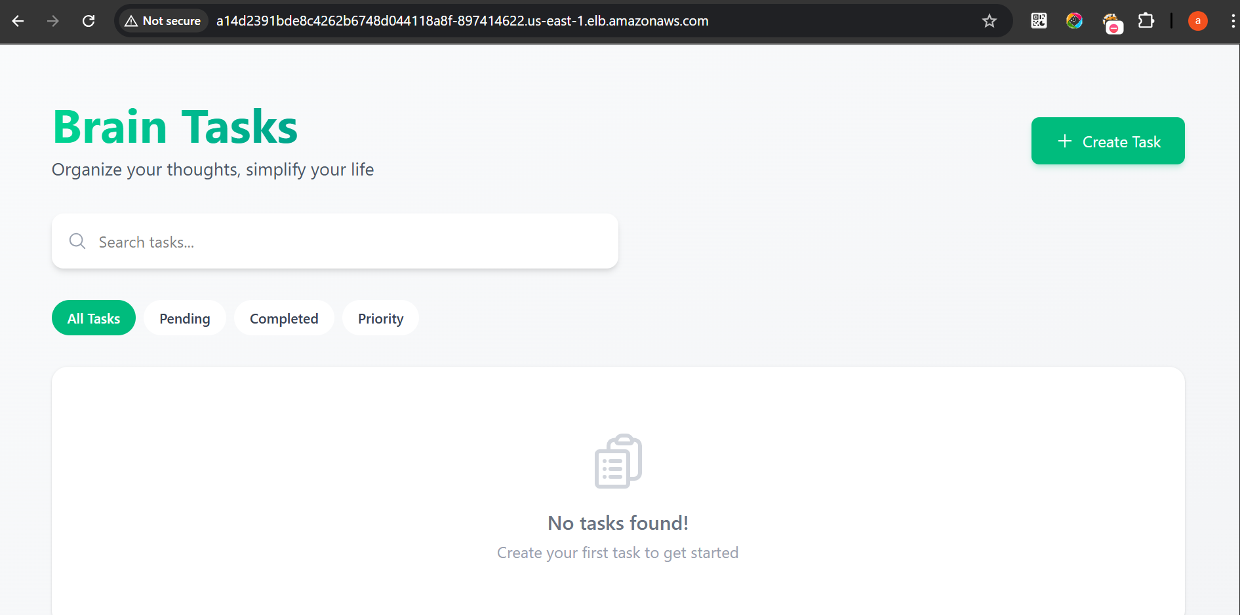

LoadBalancer ARN

LoadBalancer ARN
